Listening

Meet the children 
<SB S.XXX>
- Text 1: Pets
Listen to the children. Tick (✓) what pets they have got. Write down one boy’s name.
Höre den vier Kindern zu. Setze ein Häkchen (✓) bei ihrem Haustier. Schreibe den Namen des zweiten Jungen auf.

 | 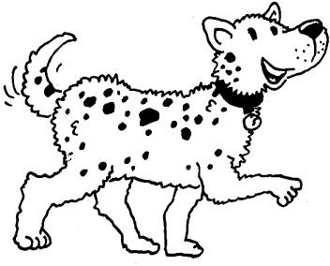 |  |  | 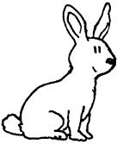
Ben
Alice
Melissa


- Text 2: About me
Listen to Alex. What has he got? What does he like? Tick (✓) the right words.
Höre Alex zu. Was hat er? Was mag er gern? Setze ein Häkchen (✓) beim richtigen Wort.
dog Morty
garden
music
pizza
sister

bike
basketball
football
spaghetti
two
brothers

- Text 3: My area
Listen to Brad and Adam. What places are there in their area? Tick (✓) the right pictures.
Höre Brad und Adam zu. Welche Orte gibt es dort, wo sie wohnen? Setze ein Häkchen (✓) bei den richtigen Bildern.

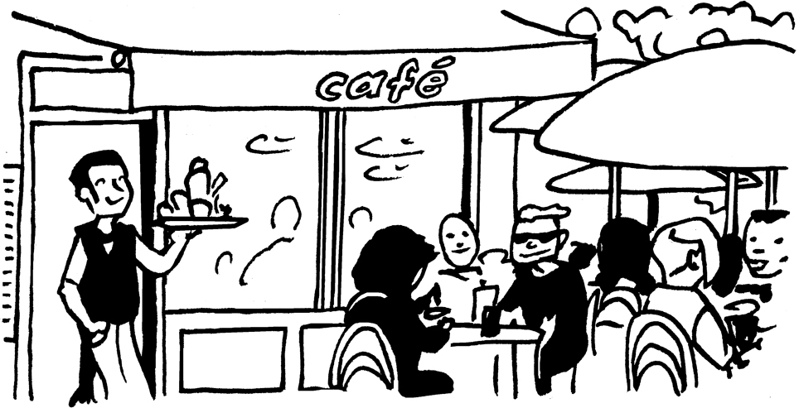 |  | 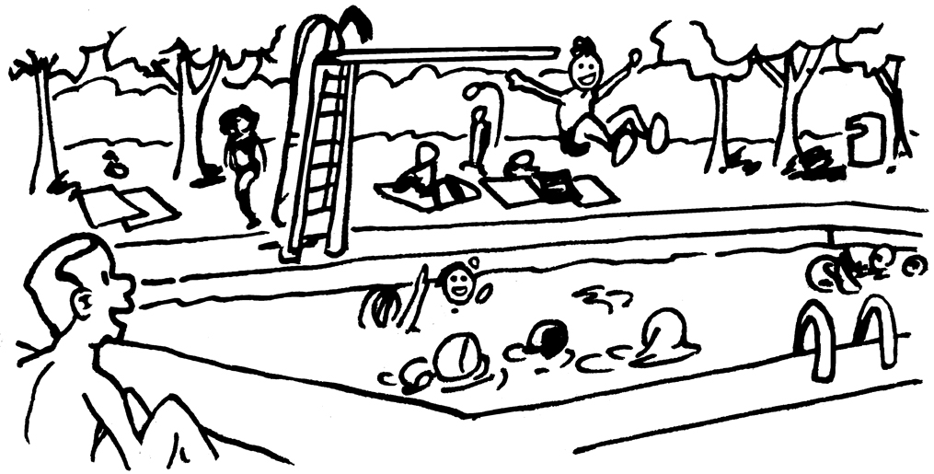 |  | 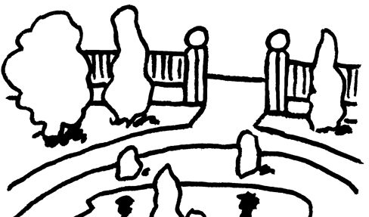 |  | 
1. |  | 2. |  | 3. |  | 4.
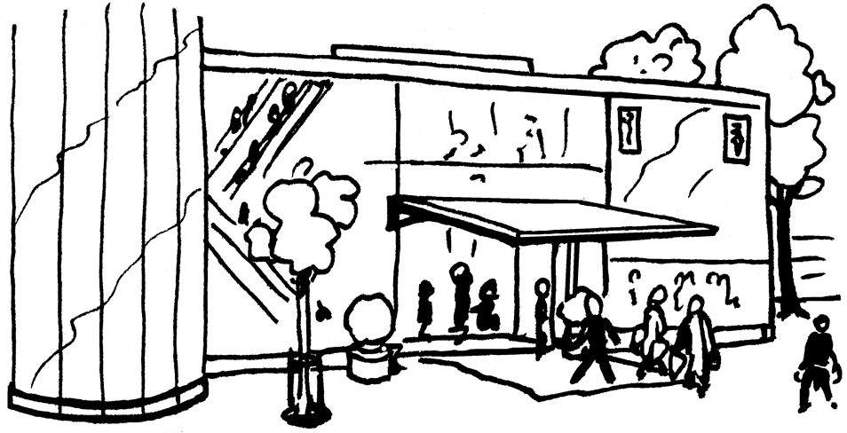 |  | 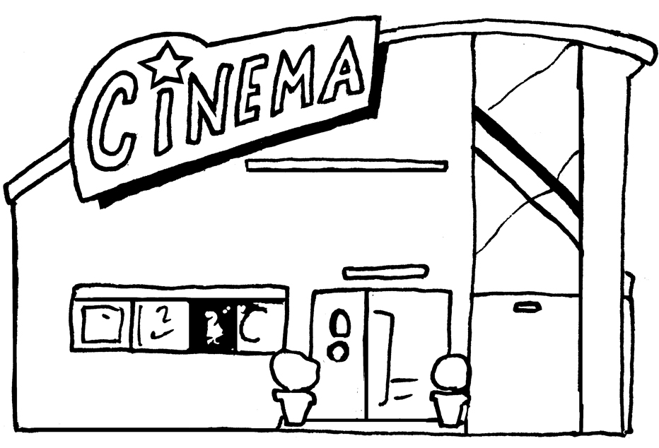 |  | 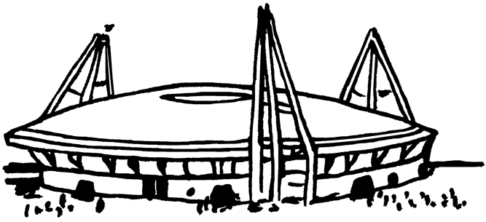 |  | 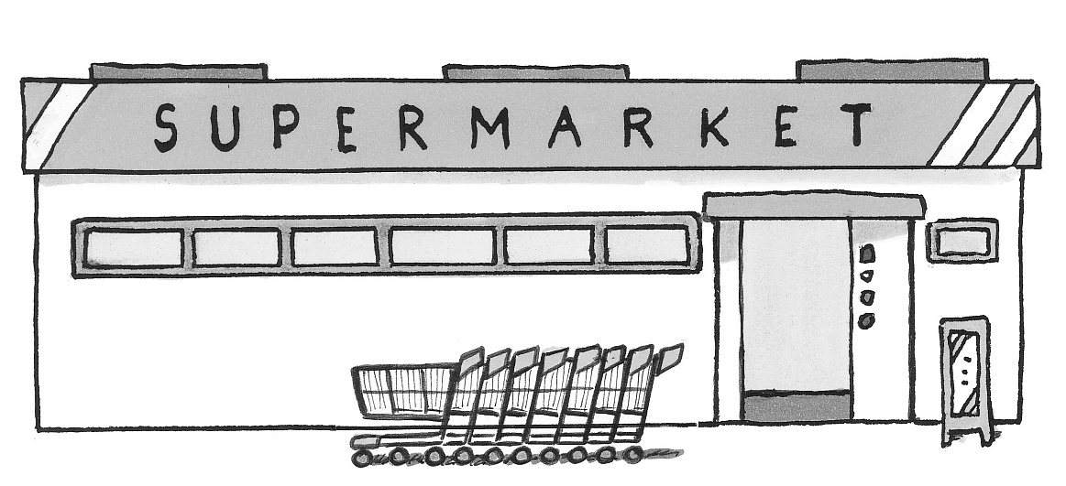
5. |  | 6. |  | 7. |  | 8.

LISTENING


British children in Europe
<SB S.XXX>
- Listen to three children from England. They live in different places now.
Tick (✓) the right answers. Sometimes you can tick more than one answer.
Höre drei Kindern aus England zu. Sie leben nun in anderen Ländern. Setze ein Häkchen (✓) unter den richtigen Namen. Manchmal sind mehrere Antworten richtig.

Who … | Ben | Fatima | Sara
1. is eleven years old?
2. has got a a big swimming pool in his/her area?
3. does sport in the park?
4. goes to the shopping centre?
5. loves ice cream?
6. says there are lots of museums in his/her city?

- Choose one child: Ben, Fatima or Sara. Then listen again and write down facts about him/her.
Wähle ein Kind aus: Ben, Fatima oder Sara. Höre dann den Text noch einmal an und schreibe Informationen über das Kind auf.
Name? ______________________ Age? _________________________

Brothers or sisters? ______________________________________________

______________________________________________________________

Town? ________________________________________________________

Hobbies? ______________________________________________________

______________________________________________________________

Reading

Semra’s email
<SB S.XXX>
Read Semra’s email to her friend Gillian.
Lies die E-Mail von Semra an ihre Freundin Gillian.

Semra lives in Camden now. This is her email to her friend Gillian:
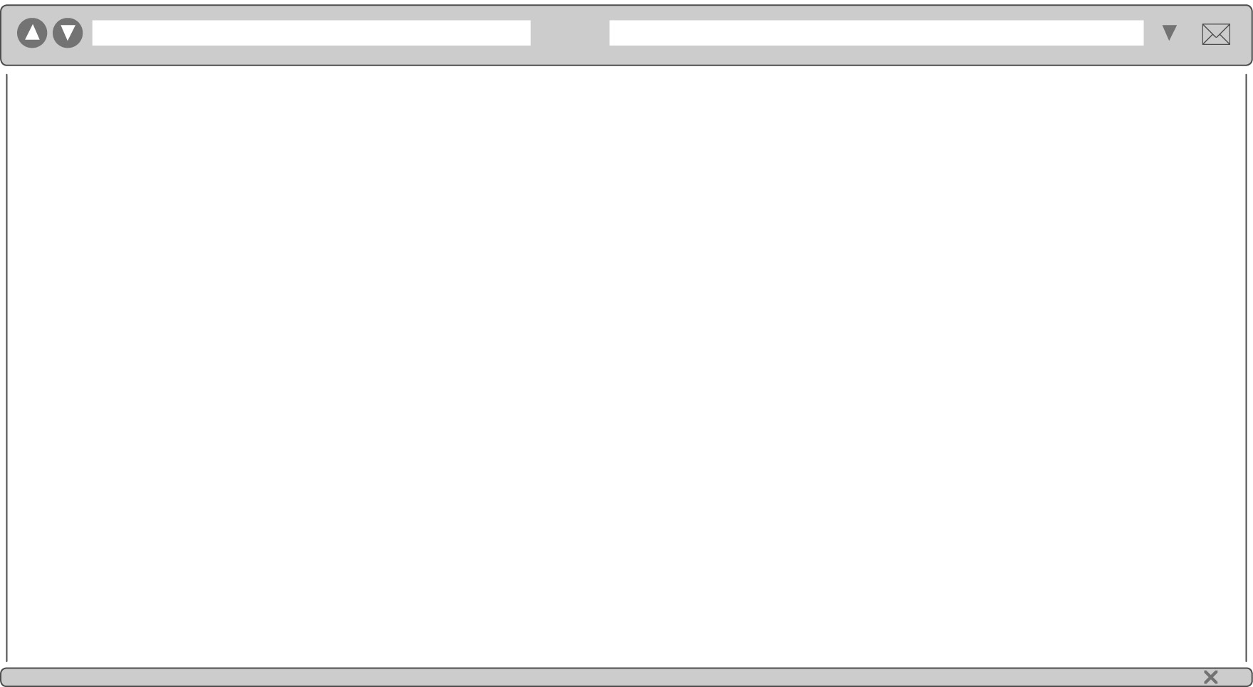

Hi Gillian,

How are you? Camden is great! I really like my new school. It is called Hampstead School. The teachers are all very nice and I’ve got three new friends. Their names are Abby, Zuleika and Tom. They are all in my class. There is a swimming pool in our area. Abby, Zuleika and I like to go there. I’ve got a little dog now. His name is Dino and he is black and white. My friends have got pets, too. Abby has got two rabbits, Mr and Mrs Smith. They are in the garden in summer. Zuleika has got a cat. His name is Bob. Tom has got four fish. I like dogs, rabbits and cats, but I don’t like fish
as pets. There is a cool café in our street. I can meet my friends there.
That’s lots of fun!
And we have a big park here! We can ride our bikes or play in the
playground – it’s really cool! You should come and play with us one day!

Write back soon!

Bye,
Semra

- Match the children with their pets. Write the number under the right name.
Ordne den Kindern ihre Haustiere zu. Schreibe die Zahl unter den richtigen Namen.
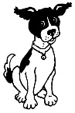
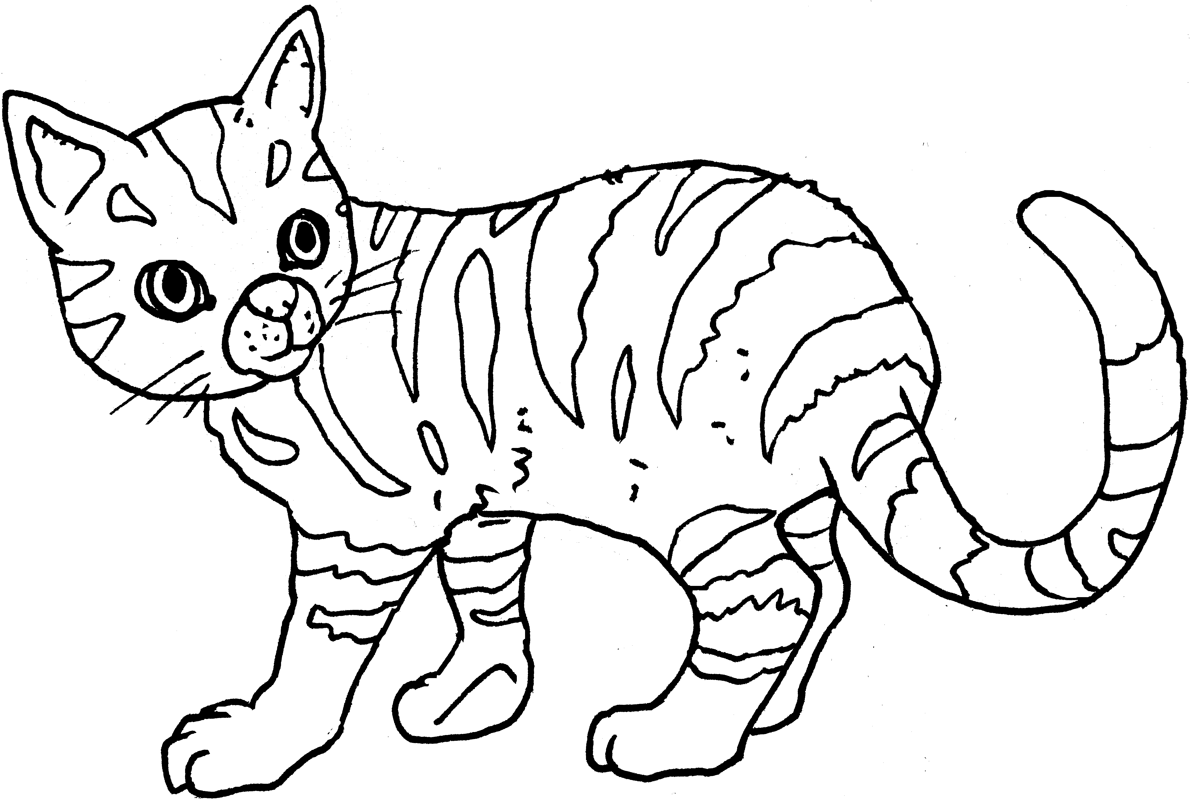
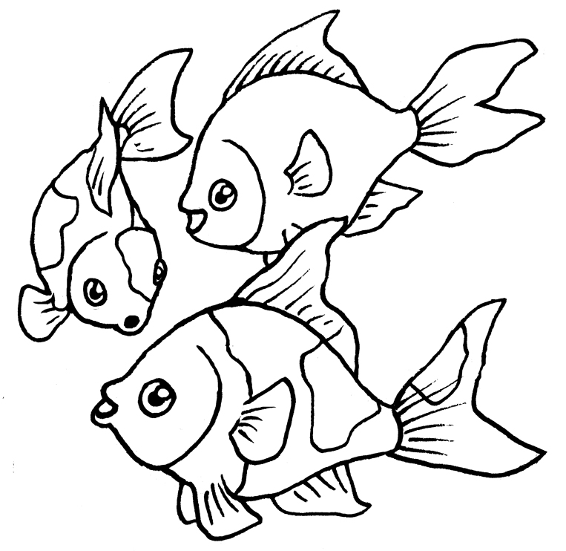
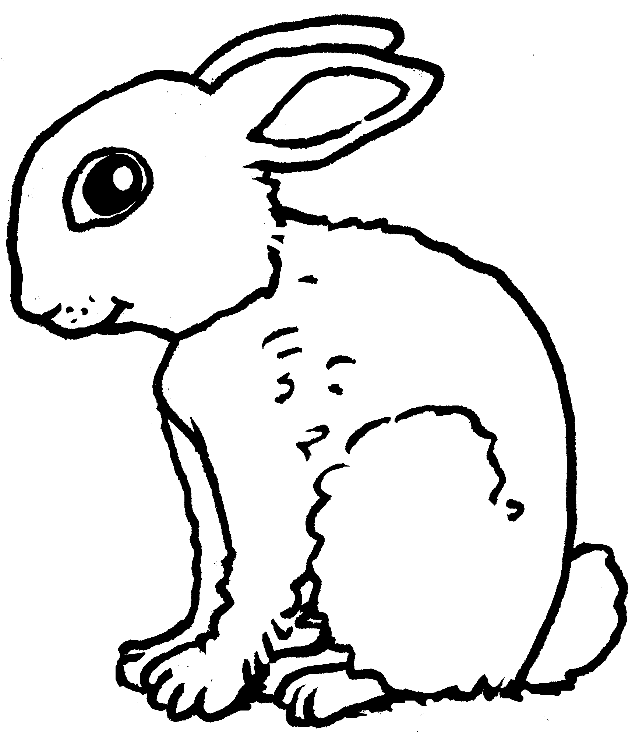

1 2 3 4

Semra | Abby | Zuleika | Tom

- What places are in Semra’s area? Tick (✓) the right words.
Welche Orte gibt es in Semra’s Gegend? Setze ein Häckchen (✓) bei den richtigen Wörtern.

café
park
cinema
bike shop

supermarket
swimming pool

Semra’s email
<SB S.XXX>
Read Semra’s email to her friend Gillian.
Lies die E-Mail von Semra an ihre Freundin Gillian.

Semra lives in Camden now. This is her email to her friend Gillian:

Hi Gillian,

How are you? Camden is great! I really like my new school. It is called Hampstead School. The teachers are all very nice and I’ve got three new friends. Their names are Abby, Zuleika and Tom. They are all in my class. There is a swimming pool in our area. Abby, Zuleika and I like to go there. That’s lots of fun!
I’ve got a little dog now. His name is Dino and he is black and white. My friends have got pets, too. Abby has got two rabbits, Mr and Mrs Smith. They are in the garden in summer. Zuleika has got a cat. His name is Bob. Tom has got four fish. I like dogs, rabbits and cats, but I don’t like fish as pets. There is a cool café in our street. I can meet my friends there. And we have a big park here! We can ride our bikes or play in the playground – it’s really cool! You should come and play with us one day!

Write back soon!

Bye,
Semra

Read the sentences. Tick (✓) right or wrong.
Lies die Sätze. Setze ein Häkchen (✓) für richtig oder falsch.

right wrong
  - Semra’s new friends are all in her class. –––––––––––––––––––––––––––––
  - Semra’s new dog is called Spot. –––––––––––––––––––––––––––––––––––
  - Her friend Tom has got three fish as pets. ––––––––––––––––––––––––––––

  - There is a big park in her area. –––––––––––––––––––––––––––––––––––––
  - Semra and her friends don’t like the playground in the park. ––––––––––––––

Semra’s email
<SB S.XXX>
Read Semra’s email to her friend Gillian.
Lies die E-Mail von Semra an ihre Freundin Gillian.

Semra lives in Camden now. This is her email to her friend Gillian.

Hi Gillian,

How are you? Camden is great! I really like my new school. It is called Hampstead School. The teachers are all very nice and I’ve got three new friends. Their names are Abby, Zuleika and Tom. They are all in my class. There is a swimming pool in our area. Abby, Zuleika and I like to go there. That’s lots of fun!
I’ve got a little dog now. His name is Dino and he is black and white. My friends have got pets, too. Abby has got two rabbits, Mr and Mrs Smith. They are in the garden in summer. Zuleika has got a cat. His name is Bob. Tom has got four fish. I like dogs, rabbits and cats, but I don’t like fish as pets. There is a cool café in our street. I can meet my friends there. And we have a big park here! We can ride our bikes or play in the playground – it’s really cool! You should come and play with us one day!

Write back soon!

Bye,
Semra

Write down facts about Semra.
Schreibe Informationen über Semra auf.
Name: Semra
Town:
Name of school:
Hobbies:
Pets she likes:
Name of her pet:
Friends:
Favourite places:

Writing
<SB S.XXX>

Facts about my area

<SB S.XXX>
Write about your area. Where do you live? What have you got? What haven’t you got? Write about 40 words. Write at least two sentences with “I have got…” and two sentences “I haven’t got…”
Schreibe einen Text über deine Gegend. Wo lebst du?
Was gibt es dort? Was gibt es dort nicht? Schreibe ungefähr 40 Wörter. Schreibe mindestens 2 Sätze mit “I have got…” und 2 Sätze mit “I haven’t got…”
_____________________________________________________________________
_____________________________________________________________________
_____________________________________________________________________
_____________________________________________________________________
_____________________________________________________________________
_____________________________________________________________________

_____________________________________________________________________
_____________________________________________________________________
Facts about my area

<SB S.XXX>
<SB S.XXX>
Write about your area. Where do you live? What have you got? What haven’t
you got? Write about 50–60 words. Write at least three sentences with “I have got…” and three sentences with “I haven’t got…”
Schreibe einen Text über deine Gegend. Wo lebst du?
Was gibt es dort? Was gibt es dort nicht? Schreibe ungefähr 50–60 Wörter. Schreibe mindestens 3 Sätze mit “I have got…” und 3 Sätze mit “I haven’t got…”

_____________________________________________________________________
_____________________________________________________________________
_____________________________________________________________________
_____________________________________________________________________
_____________________________________________________________________
_____________________________________________________________________
_____________________________________________________________________
_____________________________________________________________________
_____________________________________________________________________
_____________________________________________________________________

_____________________________________________________________________
_____________________________________________________________________

